Chris Messmann

11/24/20

IT FDN 110 A Au20: Foundations of Programming: Python

Assignment 06

Assignment 06: Working with Functions and Classes

**Introduction**

Assignment 06 utilizes all the features of Assignment05 (links and dictionaries) but uses classes and functions to organize and control the flow of information received into and out of the program. Assignment06 also gives the user a choice on which record to remove when selecting ‘remove record’ option from the menu.

Figure 1a-1g are snapshots of the Python code. Figure 2 is a snapshot of the program working in the command window. Figure 3 is a snapshot of the program working out of the shell window. Figure 4 is a snapshot of the text document where the user information is retrieved and recorded.

Figure 1a (Python code)

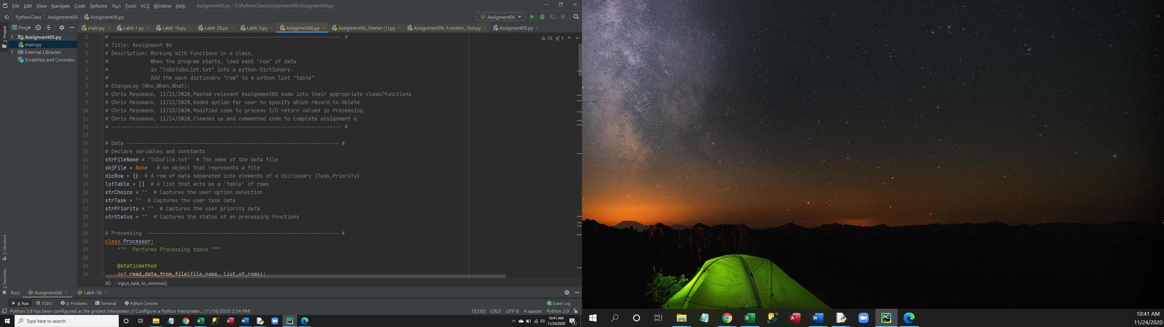

Figure 1b (Python code)

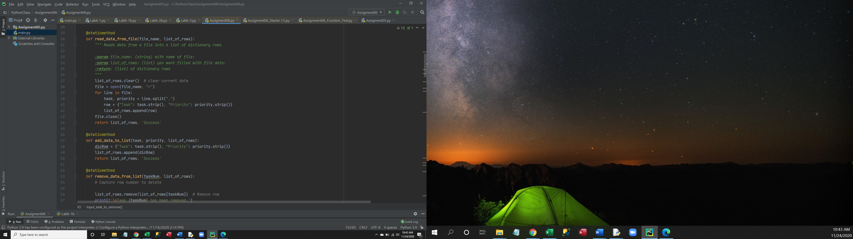

Figure 1c (Python code)

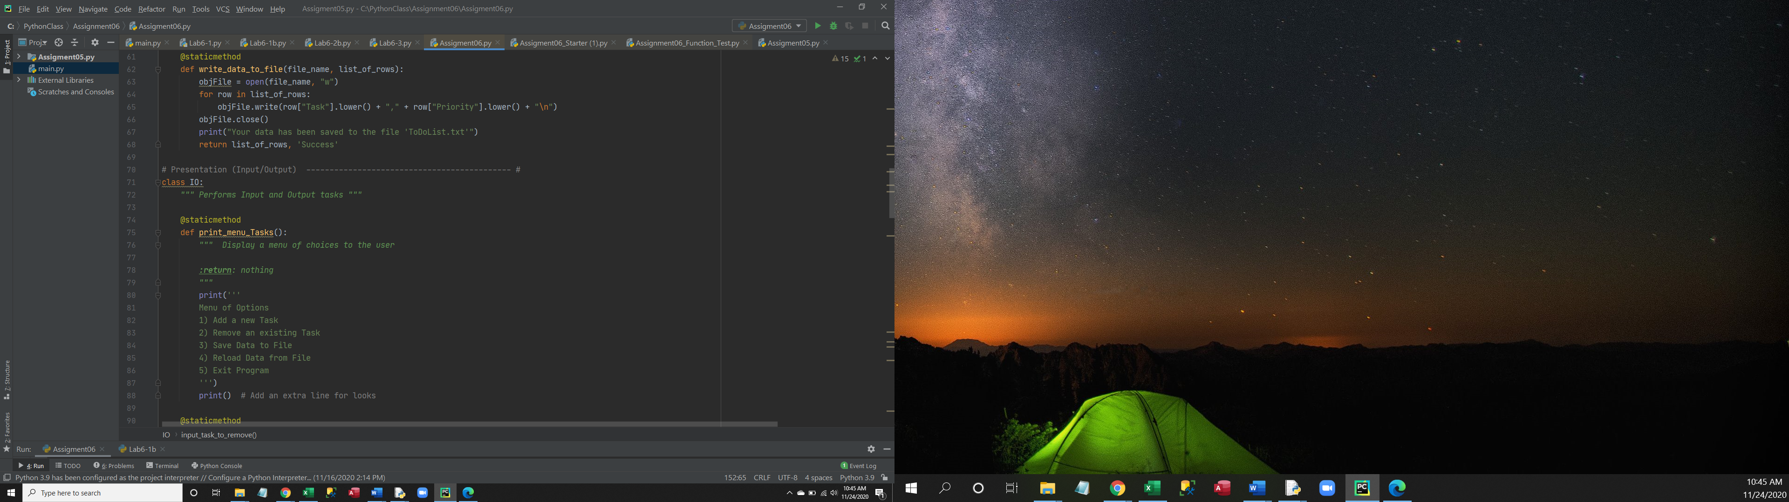

Figure 1d (Python code)

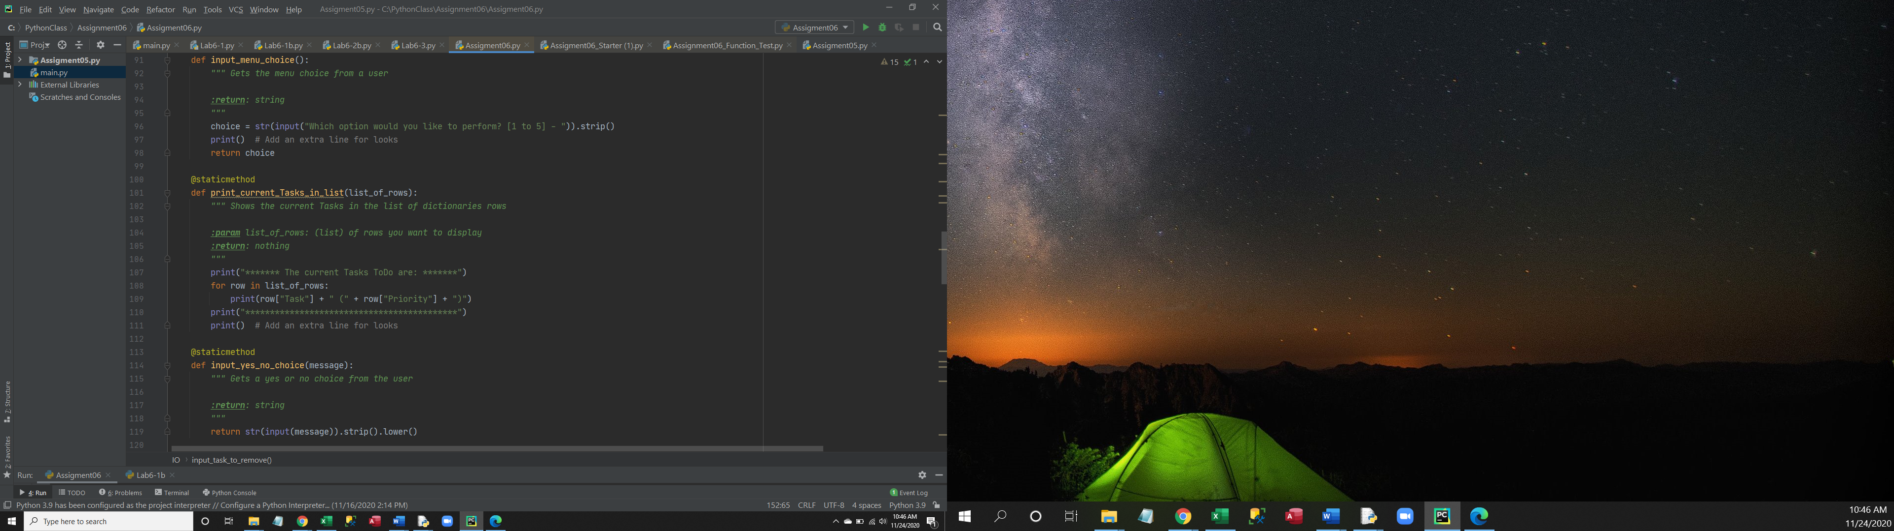

Figure 1e (Python code)

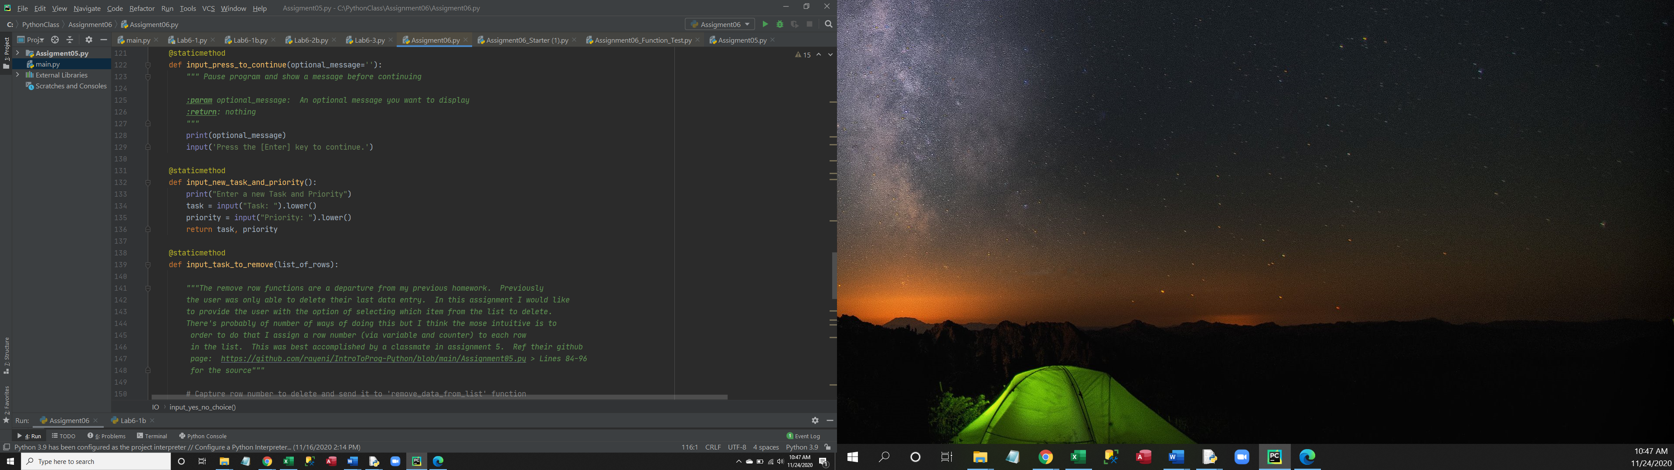

Figure 1f (Pthon code)

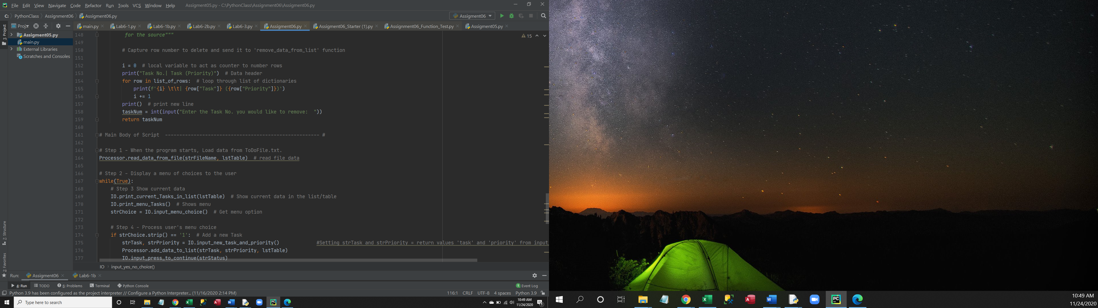

Figure 1g (Python code)

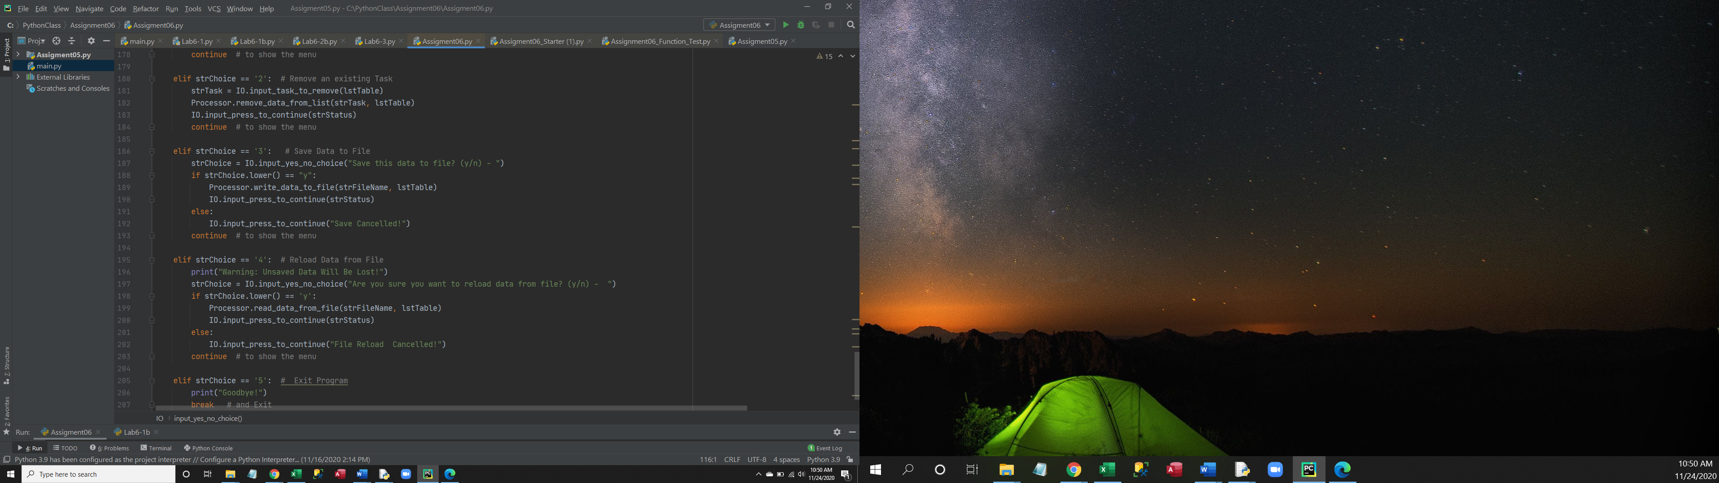

Figure 2a (Command window)

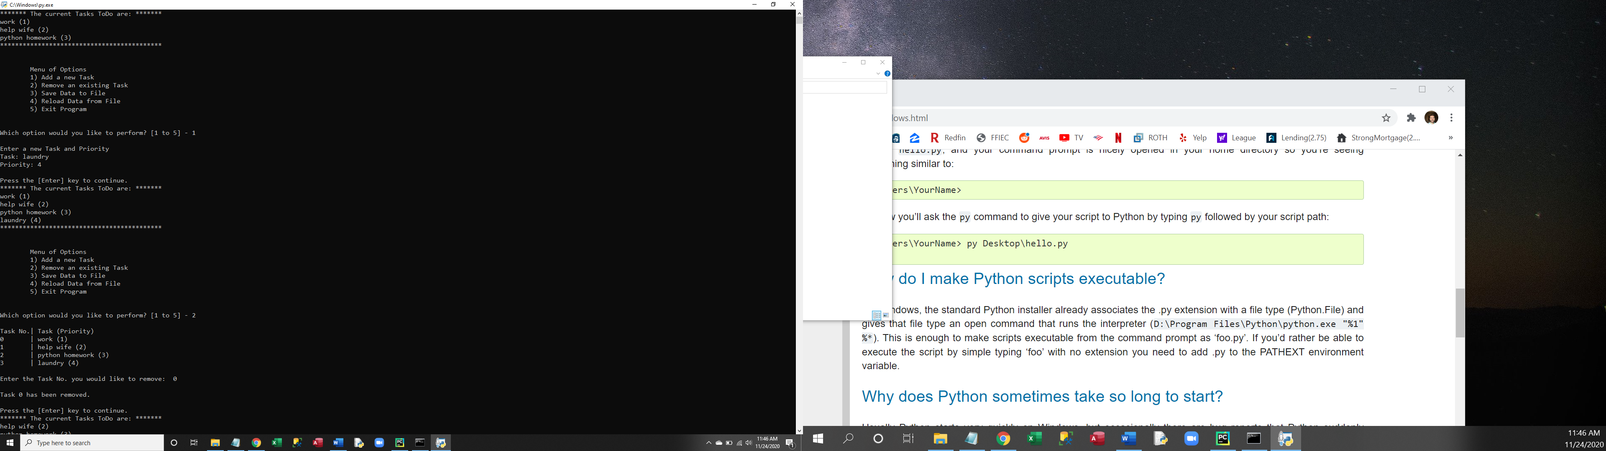

Figure 2b (Command window)

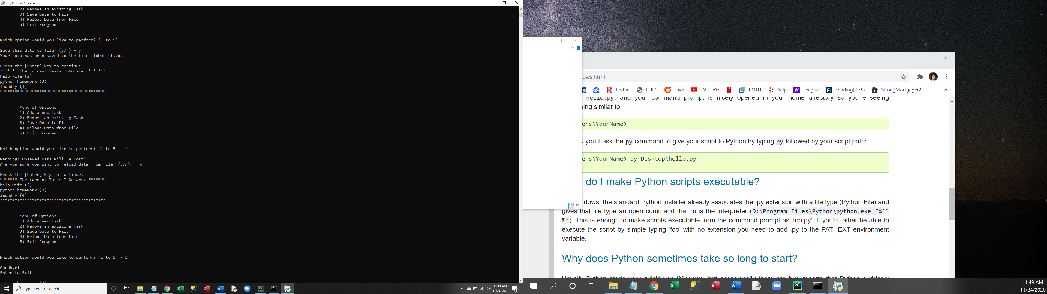

Figure 3 (Shell window)

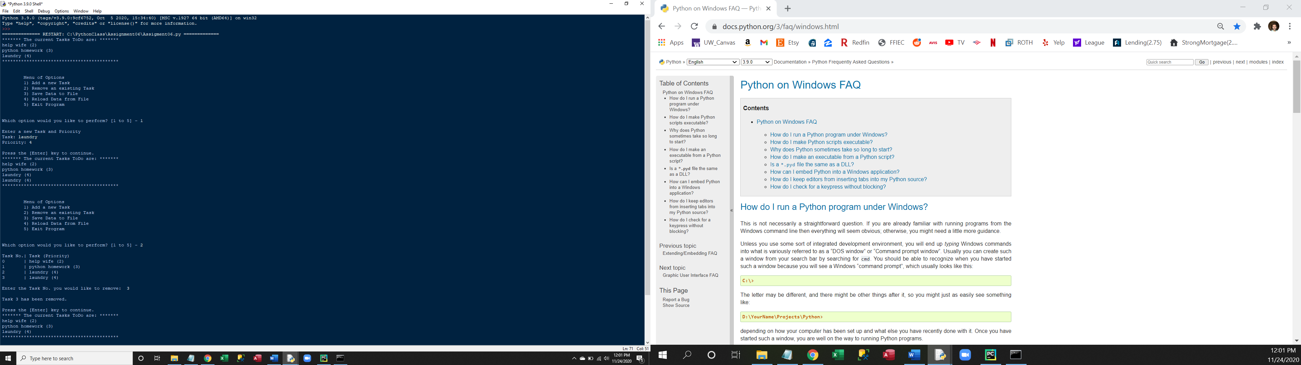

Figure 4 (ToDoList.txt Text document)

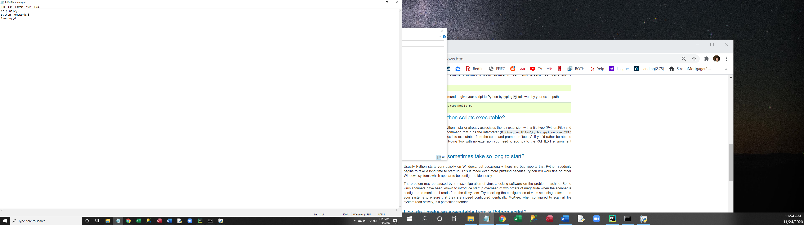

**Summary**

In summary Assignment 06 is a revision of Assignment05 where a user is presented with a list of options for managing a priority list of tasks. New functionality from Assignment06 organizes and controls the flow of information through the program by way of classes and functions. Like Assignment05 the program makes use of dictionaries and lists to record information from a text file and user. Also, like Assignment05, the user has the option of saving the changes they made to their list by writing the contents of the list to a text file (ToDoFile.txt).